Project Design Phase-II

**Data Flow Diagram & User Stories**

|  |  |
| --- | --- |
| Date | 03 October 2022 |
| Team ID | PNT2022TMID11612 |
| Project Name | Web Phishing Detection |
| Maximum Marks | 4 Marks |

**Data Flow Diagrams:**

A Data Flow Diagram (DFD) is a traditional visual representation of the information flows within a system. A neat and clear DFD can depict the right amount of the system requirement graphically. It shows how data enters and leaves the system, what changes the information, and where data is stored.

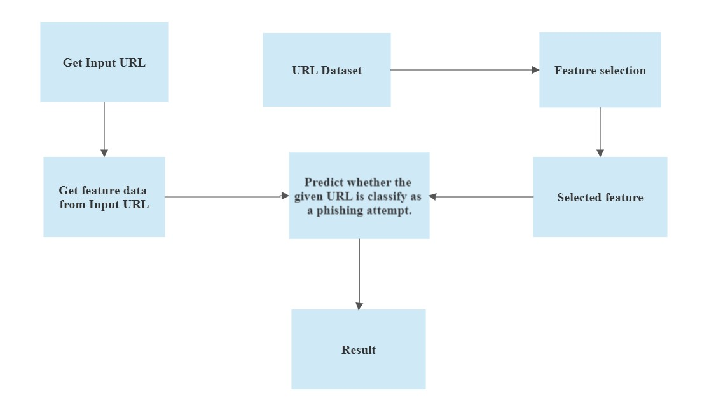

**User Stories**

Use the below template to list all the user stories for the product.

|  |  |  |  |  |  |  |
| --- | --- | --- | --- | --- | --- | --- |
| **User Type** | **Functional**  **Requirement (Epic)** | **User Story**  **Number** | **User Story / Task** | **Acceptance criteria** | **Priority** | **Release** |
| Customer  (Mobile user) | Input URL | USN-1 | As a user, I can input the particular URL | Can access the website | High | Sprint-1 |
| Customer (Web user) | Input URL | USN-2 | As a user, I am waiting for verification | Access the legitimate website | High | Sprint-1 |
| Customer Care Executive | Extract input URL feature | USN-3 | Need to extract the required feature from the URL which is given by the user | Can compare the websites | High | Sprint-1 |
| Administrator | Guessing whether the URL is legitimate | USN-4 | Predicting the URL using the ML algorithm | ML algorithm gives correct prediction | High | Sprint-2 |
|  | Result | USN-5 | Then the data is used to make the result | To find correct classifier for produce the result | High | Sprint-2 |